SALES SQL PROJECT

1 – Total sales generated by the business.
SELECT
ROUND(SUM(sales), 1) AS Total_sales
FROM
Sales_Data;
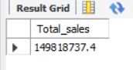
2 - Total profit earned by the business.
SELECT
COUNT(order_id) AS Total_order
FROM
sales_data;
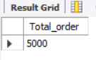
3 - Total number of unique customers.
SELECT
COUNT(DISTINCT Customer_id) AS Total_customer
FROM
sales_data;
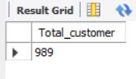
4 - Average value of each customer order.
SELECT
ROUND(AVG(sales), 1) AS Average_Customer_Value
FROM
sales_data;
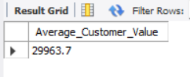
5 - Analyze sales performance across different product categories.
SELECT
Category AS Categories,
ROUND(SUM(sales), 1) AS Categories_wise_sales
FROM
sales_data
GROUP BY Category;
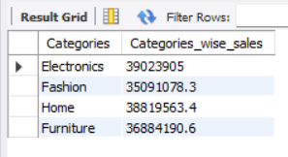
5 - Evaluate profit generated by each product category.
SELECT
category AS category,
ROUND(SUM(profit), 1) AS Category_wise_profit
FROM
sales_data GROUP BY category;
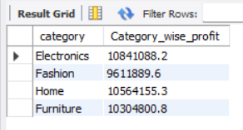
6 - Top 10 products by total sales.
SELECT
Product AS Products,
round(SUM(Sales),1 ) Total_Sales
FROM sales_data
GROUP BY Product
ORDER BY Total_Sales DESC
LIMIT 10;
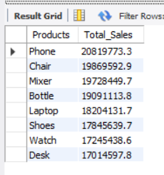
7 - Identify the bottom 10 products by total sales.
SELECT
Product AS Products, ROUND(SUM(sales), 1) AS Total_sales
FROM sales_data
GROUP BY Product
ORDER BY Total_sales Asc
LIMIT 10;
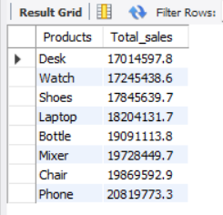
8 - Analyze the monthly sales trend over the selected period.
SELECT
MONTH(order_date) AS Monthly_Trend,
MONTHNAME(order_date) AS Month_name,
ROUND(SUM(sales), 1)
FROM
sales_data
GROUP BY MONTH(order_date) , MONTHNAME(order_date)
ORDER BY MONTH(order_date);
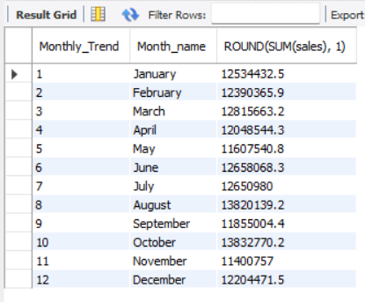

9 - Analyze the monthly profit trend over time.
SELECT
MONTH(order_date) AS Month_Trend,
MONTHNAME(order_date) AS Month_Name,
ROUND(SUM(profit), 1) AS Monthly_Profit
FROM sales_data
GROUP BY MONTH(order_date) , MONTHNAME(order_date)
ORDER BY MONTH(order_date);

10 - Compare sales performance across different regions .
SELECT
region, ROUND(SUM(sales), 1) AS Region_wise_sales
FROM sales_data
GROUP BY region;
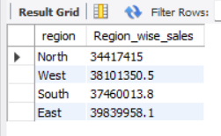

11 - Compare sales performance across different cities.
SELECT
city AS City, ROUND(SUM(sales), 1) City_wise_sales
FROM
sales_data
GROUP BY city;
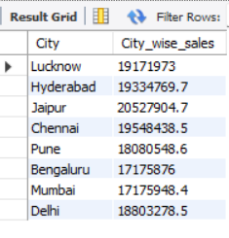
12 - Analyze customer preferences for payment methods.
SELECT
payment_method AS Payment_Method,
COUNT(DISTINCT customer_id) AS No_of_customers
FROM
sales_data
GROUP BY payment_method;
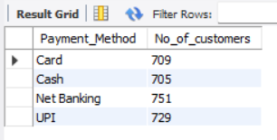

13 - Identify the top customers based on total sales.
SELECT
customer_id,
customer_name,
ROUND(SUM(sales), 1) AS Total_sales
FROM
sales_data
GROUP BY customer_id , customer_name
ORDER BY Total_sales DESC
LIMIT 10;
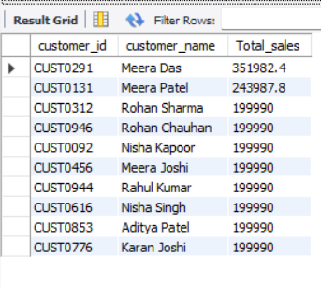
14 - Identify top 5 customers who made repeat purchases.
SELECT
Customer_ID,
COUNT(Order_ID) AS Total_Orders
FROM sales_data
GROUP BY Customer_ID
HAVING COUNT(Order_ID) > 1
ORDER BY Total_Orders DESC;
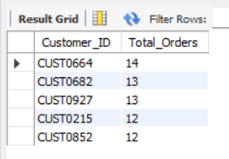

15 - Analyze the total quantity sold by each product.
SELECT
product, SUM(quantity) AS No_of_Quantity
FROM
sales_data
GROUP BY product;
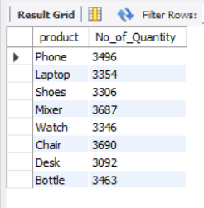
16 - Evaluate the impact of discounts on sales.
SELECT
Discount_per, ROUND(SUM(Sales), 1) AS Total_Sales
FROM sales_data
GROUP BY Discount_per
ORDER BY Discount_per;
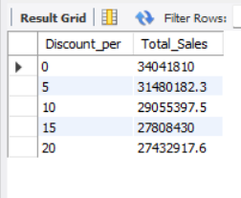

17 - Calculate the overall profit margin of the business.
SELECT
ROUND(SUM(Profit), 1) AS Total_Profit,
ROUND(SUM(Sales), 1) AS Total_Sales,
ROUND((SUM(Profit) / SUM(Sales)) * 100, 2) AS Profit_Margin_Percentage
FROM sales_data;
